Growing Places Investment Strategy
August 2022

Contents

1. Background 3
2. Current Position 5
3. SWOT 7
4. Investment Strategy 9
5. Approach to Risk 11
6. Conclusion 12

- Background

  - The Growing Places Fund (GPF) was launched in 2011 as a joint initiative of Department for Communities and Local Government (DCLG) and Department of Transport (DfT) who sought assurance that local partnerships were committed to using GPF for the provision of infrastructure and would target projects which represent good value for money.

  - When the GPF was launched, it was strongly encouraged by Government, to be used as a revolving Fund to unlock stalled investment; this has been the approach to-date in Lancashire with 100% of allocations being made in this way

  - In 2012 the Lancashire Enterprise Partnership (LEP) was allocated £19,378,944 million.
1.4 GPF has three overriding objectives,
• To generate economic activity in the short term by addressing immediate infrastructure and site constraints and promote the delivery of jobs and housing,
• To allow LEP's to prioritise the infrastructure they need, empowering them to deliver their economic strategies,
• To establish sustainable revolving funds so that funding can be reinvested to unlock further development and leverage private sector investment.
  - In 2015 DCLG commissioned an Appraisal Report in England which evaluated the performance of GPF.

  - It reflected that 84% of the GPF had been awarded on a loan only basis. A minority of LEPs deployed the funds as grant only or a mixture of loan and grant. This therefore sets the precedent that LEPs can use the Fund as grant in order to meet economic needs.

  - The Lancashire LEP uses the interest generated from the GPF to pay for salaries of officers and strategic initiatives to supplement the grant funding received from government and company members in the operational budget.

  - The original funding allocation was un-ringfenced and came with the single condition that it had to be used for capital projects. In July 2020 DCLG confirmed that there were no specific conditions regarding whether repaid loans could be treated as capital or revenue when it was returned to the LEP.
  - Therefore, it can be assumed that the LEP has the flexibility to use the funds for capital, revenue or grant. For any approval of funds such as grants, the LEP needs to be aware that if grant is deployed then there will be a consequential loss of income regarding the LEP's core operating budget as well as the opportunity to recycle the funds to further projects in the future i.e. reducing the overall pot available for investment
  - For every £100k of GPF loan, the LEP could expect to receive an average return of 4% plus the Bank of England base rate.

- Current Position
  - The purpose of GPF is to grow the economy of Lancashire by bringing forward development on marginal schemes which would not have come forward if left to market forces.

  - The current criteria for GPF is a stalled scheme based in Lancashire. The funding is for development sites which include housing, infrastructure, commercial or industrial buildings. Security is always taken for the loan, usually in the form of a first charge over the land or building and the borrower pays for the legal, valuation and monitoring surveyors fees of the LEP.
2.4 The benefit of this approach has been to create an Evergreen Fund which contributes to the economic success of Lancashire. The outputs and impacts of the scheme are outlined in Section 3 below.
2.5 The nature of GPF in the alternative finance market is that schemes can take a long time to come forward. Many borrowers have not previously gone through a rigorous due diligence and monitoring process which has subsequently resulted in developers being much more robust in their approach going forward after a Growing Places scheme.
2.6 GPF has successfully brought forward development continuously since 2012 and now is the only funding available to the LEP to deploy.
2.7 Given that it is the only Fund available to the LEP then consideration should be given to how to exploit GPF to its maximum potential to impact the Lancashire economy and utilise the flexibility of the Fund.
2.8 Currently schemes come forward and are assessed on a case-by-case basis.
2.9 There are three schemes going through due diligence and due to a freeze on marketing the Fund, there are no further development sites scheme in the pipeline.
  - It is estimated that circa 80,000 workers per annum travel outside of Lancashire for highly
paid jobs to match their skill set. There are 4 jobs for every 5 people of working age which means that Lancashire need to grow the quantum of jobs in the county.
2.11 There are a number of potential options relating to inward investment, EZ development and the co-creation of an Innovation Fund. Going forward, consideration should be given to nominally splitting the Fund into 4 areas to cover
    - Development Sites – business as usual
    - Inward Investment opportunities
    - Enterprise Zone development
    - Innovation/ Manufacturing/Low Carbon Fund - to be externally managed
    - A closer alignment with LEP sectoral priorities and sector action plans.

2.12 As of 31 July 2022 the Growing Places loan has delivered the following outputs.
Measure | Output
Number of completed schemes | 10
Number of schemes on site | 1
Value of loans | £38,923,089
Value of loans repaid | £37,207,520
Private sector investment | £107,301,465
Interest received on loans | £2,177,036
Square Foot/Square Metres developed | 2,125,128 Sq Ft (201,563 sqm) buildings plus 215,278 sq ft (20,000 sqm) public realm
Jobs created | 2,135
Housing units delivered | 776

  - Types of schemes developed.
Type of scheme | Number
Commercial | 2
Mixed Use | 2
Housing | 2
Land remediation | 1
Infrastructure | 1
Retail | 1
Leisure | 1
Total | 10

  - The impact of GPF has been to support private sector development on the back of public sector investment in places such as in Burnley, Wyre and Pendle. GPF schemes have come forward as a result of public sector investment via the Growth Deal or Getting Building Fund programmes and has widened the impact of those schemes.

  - It has supported Local Authority strategic aims in West Lancashire and Preston with GPF schemes kick starting regeneration in those boroughs as developers had the confidence to realise their ambitions. In these instances, the banks were not prepared to lend to the borrowers. Again, further private sector development has ensued.

  - It has enabled new developers in Lancashire to start their development journey thereby growing capacity in the market.

3. SWOT
3.1 The SWOT analysis presented below is based on the performance of GPF over 10 years and sets out the strengths, weaknesses, threats and opportunities for the Fund going forward.

Strengths  - Successful deployment of funds creating private sector leverage, jobs, housing units, infrastructure and development space  - Evergreen Fund created  - Operated on a commercial basis  - Capital recycled  - Creates income for the LEP  - Only pot of money now available to the LEP to deploy | Weaknesses  - Not widely deployed  - Fund size cannot be increased  - Currently only used for stalled sites  - Slow process through due diligence can deter borrowers
Opportunities  - Other uses could be investigated due to new flexibilities  - Could support inward investment on a capital or revenue basis  - Could support development on Samlesbury Enterprise Zone on a capital basis  - Could support expansion development projects on a capital basis  - Could provide revenue funding into an Innovation Fund for Lancashire | Threats  - LEP budgets squeezed due to LEP Review and may been needed for operational activity  - Grant use would deplete the Fund  - No money currently available to increase the size of the pot  - Uncertainty of use of funds after merger of LEP into County Combined Authority  - Other competing public sector funds such as the Lancashire Urban Development Fund, the Northern Powerhouse Investment Fund and Rosebud  - UK Government Recovery Loan Scheme

3.2 GPF has successfully deployed loan funds that have delivered significant outputs and generated over £2m of interest as income for the LEP.

3.3 It is run on a commercial basis and each loan is judged on its own merit with the interest rate set according to the EU Reference Rate. This takes into consideration the value of the security and the strength of covenant of the borrower.

3.4 However, GPF is not oversubscribed and needs to be marketed to fully utilise the funds.

3.5 Funds left on deposit with LCC attract a rate of interest of 0.1% the funds deployed attract a much higher rate of interest to reflect the risk taken in investment. Also funds on deposit are not being utilised to support the Lancashire economy.

3.6 As GPF is the only pot of funding available to the LEP to support economic development there could be a number of calls on it.
3.7 With the new flexibilities available to GPF, consideration should be given to expand the uses of the Fund on a loan basis in order to have greater economic impact. If it's used as grant then there will be less funding for future use and less income for the LEP.
3.8 GPF has been used as capital funding and the recently launched Lancashire Urban Development Fund also provides capital funding for office, commercial and industrial buildings. GPF can work in conjunction with this Fund but to date no joint schemes have come forward. It should be noted that the Urban Development Fund cannot support housing development.
3.9 The Northern Powerhouse Investment Fund and Rosebud provide revenue funding for Lancashire businesses. The recent Availability of Finance in Lancashire report (July 2022) highlighted that apart from early seed funding there wasn't a lack of funding for businesses in Lancashire.
3.10 GPF could be used to support inward investment in a capital or revenue capacity. For example, there is an opportunity to attract a nuclear imaging company into Lancashire and loan funding from Growing Places could be used for revenue and capital to attract the company to land here. Grant funding could be used but it would limit the size of the Fund going forward.
3.11 GPF could be used alone or in conjunction with another lender such as LCC to provide an attract loan package in order to attract inward investment into the county. It could be based on capital or revenue or a mixture of both.
3.12 GPF could be used in a revenue capacity to collaboratively create a new Innovation Fund such as a Low Carbon Innovation Fund with partners such as the University of Central Lancashire.

4.Investment Strategy
4.1 The Investment Strategy sets out the framework to manage the inherent risks in lending.
4.2 Growing Places is an alternative financial instrument to high street lenders and as such the viability of the scheme or creditworthiness of the borrowers may not satisfy bank lending. It is therefore an inherently riskier proposition.
4.3 Balanced against the risker proposition is the economic benefits that schemes will bring to Lancashire. Those benefits could include sq ft developed, buildings brought back into use, new infrastructure created, highly skilled new jobs created, private sector funds leveraged into Lancashire and the commercialisation of R&D.
4.4 It is proposed to adopt a generally cautious approach but be prepared to accept a higher level of risk where a lending opportunity has a strategic fit with the LEP's Sector Groups or Strategic Framework and has a significant economic impact.
4.5 Going forward, consideration should be given to nominally splitting the Fund into 4 areas to cover
    - Development Sites – business as usual
    - Inward Investment opportunities
    - Enterprise Zone development
    - Innovation/ Manufacturing/Low Carbon Fund - to be externally managed

  - This would cover the work of the LEP's Sector Groups, which are business led and provide the LEP with sector intelligence. They have developed or are in the process of developing action plans to support the businesses in their sectors. In addition to the six sector groups detailed below there are four emerging sectors.

  - Existing Sector Groups,

- Energy & Low Carbon
- Advanced Manufacturing
- Digital
- Food & Agriculture
- Health
- Tourism, Culture and Place

4.8 Emerging Sectors, as identified in the refresh of the Lancashire Innovation Plan,
  - Cyber, Digital and Secure Systems
  - Clean and Sustainable Growth
  - Advanced Mobility and Manufacturing
  - Health Analytics
4.9 Schemes coming forward for GPF should align to one of the LEP's Strategic Framework. The Strategic Framework is illustrated below but it should be noted it has been updated to reflect today's position.

Lancashire Enterprise Partnership Strategic Framework
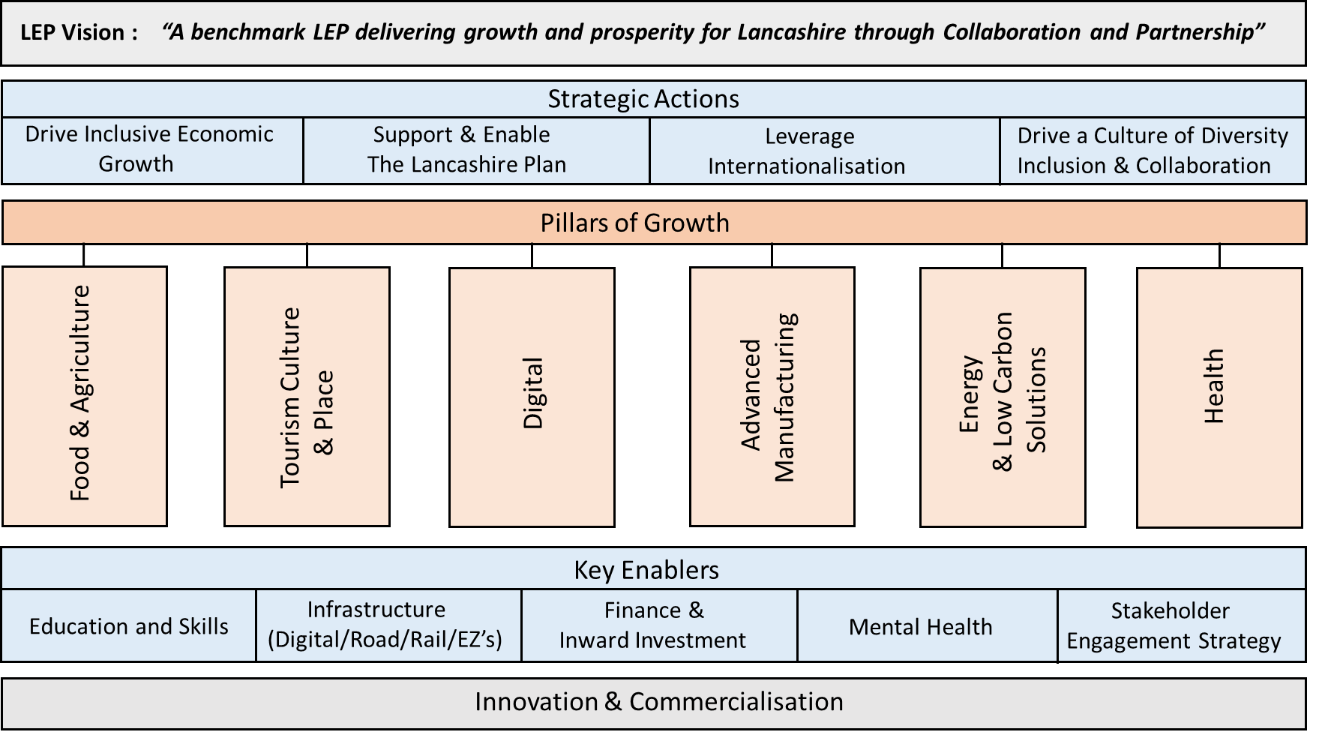
Lancashire 2050
Social Value Charter
Internationalisation Strategy

Lancashire Growth Plan
Sector Group Plans

Digital Strategy
Cultural Strategy
Stakeholder Strategy
Ref Digital Strategy
Mapping of financial provision
To be confirmed
Ref Internationalisation Strategy
New
Existing
Innovation Strategy
Skills & Employment Framework:
Future Workforce
Skilled and Productive Work
Inclusive Workforce
Informed Approach
Strategic Transport Plan
EZ Strategy Refresh

4.10 Each scheme will be assessed on its own merits but should deliver economic impact in terms of highly skilled new jobs, private sector leverage, sq.ft. developed and R&D in line with the LEP's Strategic Framework. The impact should address at least one of the above elements.
4.11 In order to improve the utilisation of GPF, the purposes for which it can be used should be promoted via a targeted marketing campaign.

5. Approach to Risk

5.1 To assist decision making for investments the portfolio should be reviewed to establish how much risk the LEP Board is prepared to take.
5.2 To manage the portfolio, the loans are RAG rated according to how they are performing as follows,

RAG Rating | Description for classification purposes
Red | - New facility  - Unproven borrower or weak borrower creditworthiness  - Issues arising with the development  - Reliant on security valuations to cover amount drawn down  - Impact will be significant but risky proposition
Amber | - Facility not all drawn but development progressing in line with expectations  - Medium borrower creditworthiness  - Facility in process of repayment  - Security to cover the whole value of the loan from the start  - The benefit of Outputs and Impacts starting to be delivered
Green | - Facility being repaid to schedule  - Strong borrower creditworthiness  - Solid security from the start  - Outputs and impacts being delivered in line with expectations

5.3 New loans will automatically be classed as Red, unless the borrower has a strong creditworthiness and security to cover the whole loan, in which case it will be classified as Amber. Otherwise, Red loans will over time move to Amber loans which will ultimately move to Green loans.

5.4 It is proposed that the spread of risk is based on a relatively equal split as follows,

30 % Red
40 % Amber
30 % Green

5.5 The spread of risk should be reviewed on an annual basis so that the Fund can respond to market forces.

5.6 The current portfolio is rates as follows,

Scheme | Value | Actually Drawn | Percentage of Fund | RAG Rating
 | £5,000,000 | £2,000,000 | 25.7%/10.3%
Cash | £14,378,944 | £17,378,944 | 74.3%/89.7%
Pipeline schemes
 | £1,600,000 | 0 | 8.3%
 | £2,450,000 | 0 | 12.6%
 | £1,500,000 | 0 | 7.7%
Cash when funds drawn | £8,828,944 |  | 45.7%

5.7 Currently 100% of the GPF is rated as green which is a secure position but it is not fulfilling it's potential to create maximum impact.
5.8 When the pipeline schemes are drawn then the portfolio will look as follows,
28.6% Red
71.4% Green

6. Conclusion
6.1 GPF is now the only Fund available for the LEP to deploy and consideration should be given to supporting the Strategic Framework through capital and revenue loan funding.
6.2 Grant funding could be considered in exceptional circumstances where use of it would significantly impact the Lancashire economy.
6.3 GPF now has the flexibility to extend beyond its current parameters and could support the Strategic Framework through
- Continued capital development loan funding,
- Inward investment capital and revenue loan funding,
- Enterprise Zone capital funding
- Revenue funding to provide equity or loans through a Fund Manager as part of a collaboration of partners.

